Week 1 A Holy Family BNS Askea
1:Which German city was divided by a wall? Berlin [Demolished 1989]
2:In which country would you find Harvard University?
Boston, USA.
3:What does HUMIDITY
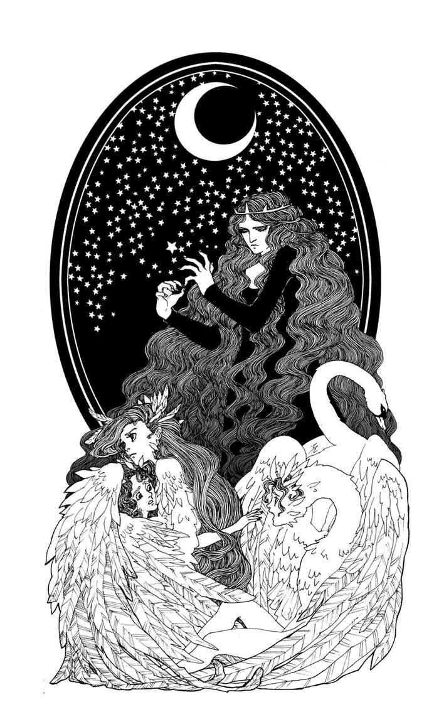
measure? The amount of water to be found in the air.
4:Which country has the second largest population in the world? India. [Largest democracy- India!]
5:Which Indian city produces more films than Hollywood? Bombay also known as Bollywood.
6:What is the highest numbered segment on a dartboard? 20.
7 :Vampire bats exist.
True or false. True.
8:What do you call the stone at the top of an arch that holds it together? The keystone.
9: What kind of light operates a solar panel? Sunlight
10: How many children had Lir? Four.
Fionnula, Aodh, Fiachra and Conn
11: What do you dry to get a Prune? A Plum.
12: In which city is the Louvre? Paris. [Home of Mona Lisa.]
13: Who put Humpty Dumpty together again? Nobody.
14: For how many years was Nelson Mandela imprisoned? 27
Nobel Peace Prize 1993,Elected President of South Africa 1994.
15: What letter of the alphabet is marked on a snooker table? D
16: What is Calligraphy? The study of handwriting. [Decorative]
[Graphology- study of character through handwriting]
17: What is the name of the day before Ash Wednesday?
Shrove Tuesday.
18: What animal’s name means River Horse? Hippopotamus.
19: What are biceps? Muscles- in your arm,.
20: How many rings in the Olympic Symbol? Five
21: Name the lost continent? Atlantis.
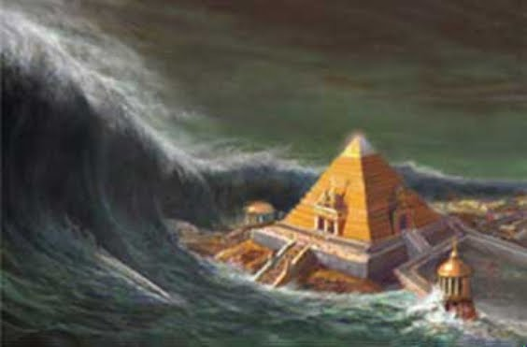
22: What was Stephenson’s rocket? A steam train.
23: The remains of what sea animal are found in bathrooms? Sponges.
24: Which famous waterfall is on the border between USA and Canada? Niagra.
25: What river flows through Galway? The Corrib.
26: How many lungs do you have? Two [Also two kidneys.]
27: Which superhero was born on the planet Krypton? Superman
28:Name the wild Australian dog? Dingo.
29: Who is the patron saint of Scotland? St. Andrew
30 Who was “The Big Fellow” in Irish politics?
Michael Collins.
31: What British Admiral was killed at the Battle of Trafalgar? Admiral Nelson
32: What is the largest planet in the solar system? Jupiter
33: How many stripes are there on Adidas clothing? 3
34: What colour is a female blackbird? Brown.
35: In which European city would you find the Trevi fountain? Rome
36: How many planets in the solar system? As of 2006, eight planets. Pluto is now considered a dwarf planet.
“My very excellent marster JUST served us noodles.”
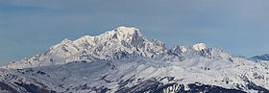
37: What is the highest mountain peak in the Alps? Mont Blanc.
38: What is the highest mountain in Europe?
Mount Elbrus. [Russian Caucasus.]
39: Which mammal can fly? The bat.
40: Why were Wilbur and Orville Wright famous? They made the first flight in a powered plane in 1903 at Kittyhawk.
41:Which river flows through Liverpool in England?
The Mersey.
42: In which social media would you find hashtags #? Twitter
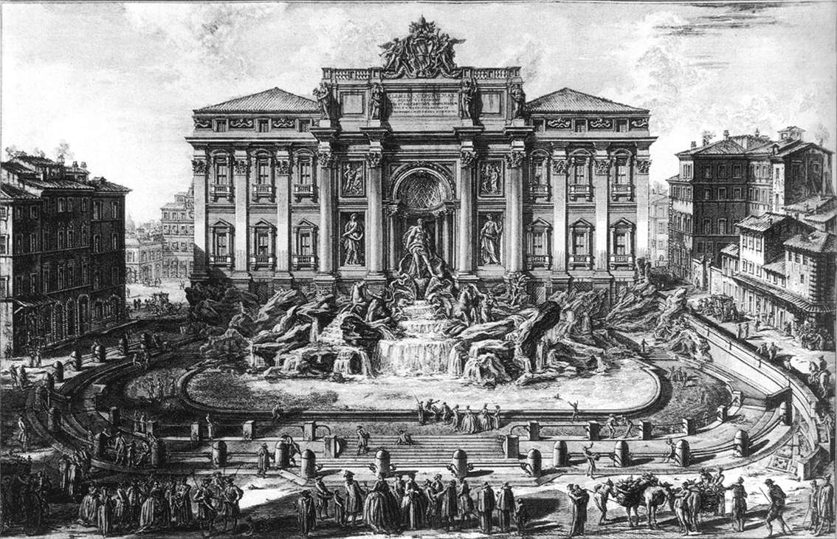

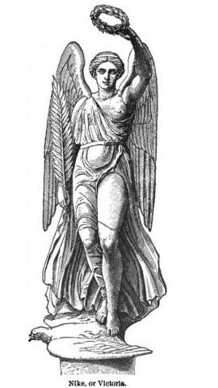
43: What does the F in John F Kennedy stand for? Fitzgerald.
44: How many humps has a Dromedary Camel, Ship of the Desert? One.
D has one hump!
Bactrian Camel Two humps like B
45: Who is the only male person that has won six consecutive All Ireland Final medals? Jack Lynch.
46: Who are your siblings? Your brothers and sisters,
47: What symbol is used by all Government departments in Ireland? The harp.
48: What do you make models from if your hobby is origami? Paper.
49: Name the bird that sprang from its own ashes? The Phoenix.
50: What does the Beaufort scale measure? Wind speed,.
51: What is the usual colour for the centre of a dartboard? Red.
[Yellow / Gold centre for an archery target.]
52: What are canines and incisors? Teeth
53 :In what year did the Great Lockout occur in Dublin? 1913
54:How many pieces of leather make up the outside of a cricket ball. Two.
55: In judo, what is the colour of a beginners belt? White
56: Who is the Greek goddess of Victory? Nike.
57: What happens to water when it reaches 100 degrees celcius?
It starts to boil,
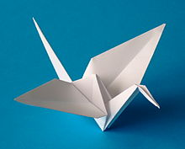
58: In what war was the battle of the Somme fought in?
World War1 [It lasted for five months!]
59: How many people do you need to run a three legged race? Four. [Eight legs!]
60: Name the world’s biggest ocean? Pacific

