Irish Question 1
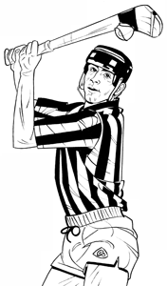
1: Which Nobel winning Irish poet wrote “Mid-Term Break”? Seamus Heaney.
2: What is the biggest county in Ireland? Co. Cork
3:What is the name of the channel which separates Ireland from Wales? St. George’s Channel.
4:What is the smallest county in Ireland? Co. Louth
5:What is the name of the trophy presented to the winners of the All-Ireland hurling title? The McCarthy Cup.
[Football-Sam Maguire]
6: What is reputed to be the oldest inhabited castle in Ireland?
Kilkea Castle, Castle Dermot, Co. Kildare.
7: Who is the manager of Ireland’s soccer team? Martin O’Neill. [Co. Derry]
8:Who was the first president of Ireland?
Douglas Hyde.
9:How many counties in the province of Leinster? Twelve.
[Munster –Largest province though!]
10:What is the smallest county in Northern Ireland?
Co. Armagh [Orchard County]
11:What is the most southern tip of Ireland?
Mizen Head.Co. Cork [Most northerly Malin Head Co Donegal]
12: In what county is Roaring Water Bay? Co. Cork.
13::What Irish Town hosts an annual writer’s week? Listowel.
Co. Kerry
14:What maritime county in Ireland has the shortest coastline? Leitrim.
15: What is the largest lake in Ireland and the United Kingdom? Lough Neagh. [America- Lake Superior. World -Caspian Sea. Africa- Lake Victoria]
16:In what year did the Catholic Emancipation Act become law? 1829 [Catholics could now vote.]
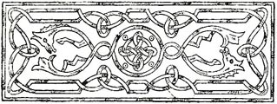
17: Who wrote the musical piece “Messiah” ? Handel
First performed in Dublin.
18: What does the letter G .in G A.A. stand for? Gaelic Athletic Association.
19: Where is the Book of Kells, written in Latin, kept?
Trinity College, Dublin.
20: What is Michael D. Higgins wife’s name? Sabina.[D is for Daniel]
21:What is Rooster a variety of? Potatoes. Developed at Oak Park
22: Name the famous Celtic brooch on display at
the National Museum? The Tara Brooch.
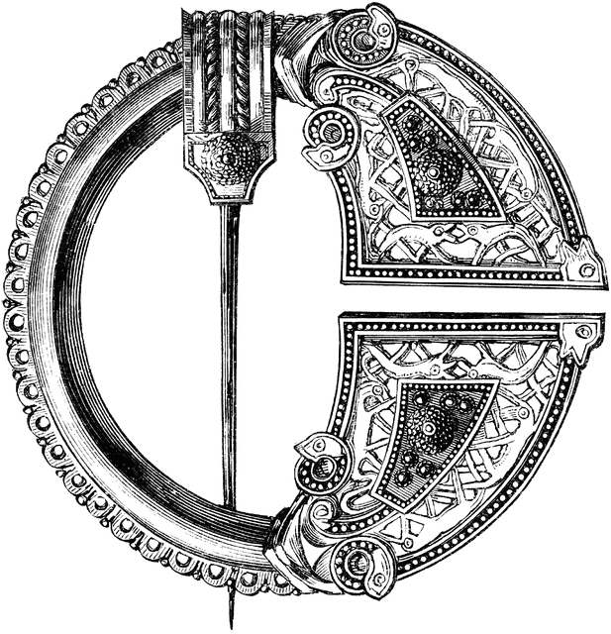
23:How many lines in a Limerick? Five.
24:Name Fionn MacCumhaill’s army. The Fianna.
25:In what year did Pope John Paul II visit Ireland? 1979
26:Where did the ancient Kings of Munster reside? Cashel.
27:Who was the second president of Ireland?
Séan T. O Ceallaigh.
28:In what county is Limerick Junction? Tipperary.
29: In what county does the Shannon rise? Cavan.[Shannon Pot]
30:What do the letters U.C.D. stand for?
University College Dublin.

