Irish Quiz Question 2 Holy Family BNS
1: Where was Eamon De Valera born? New York.
2:Name the three sister rivers? The Barrow, Nore and Suir.
3: Where were the 16 leaders of the 1916 Rising executed? Kilmainham Jail. 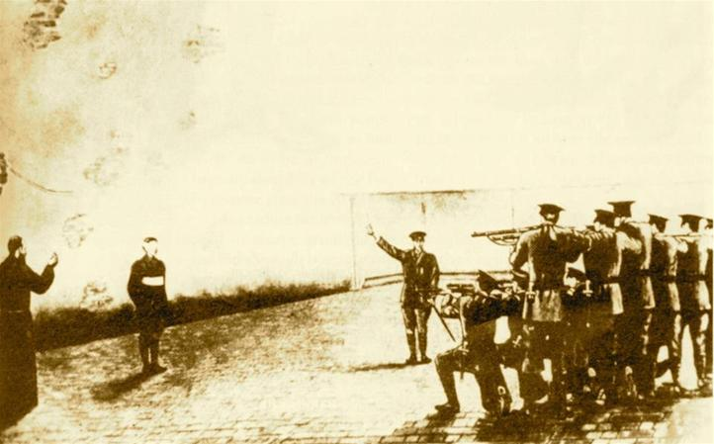
4:In what year was the GAA founded? 1884.
5:Highest point in Donegal? Mount Errigal.
6: What was Cuchulainn’s name? Setanta
7:Name the largest of the four provinces in Ireland? Munster.
8: Who acts as Mrs. Brown? Brendan O Carroll.
9: Who is the Grand Marshal of the Dublin St. Patrick’s parade 2015? Brendan O’Carroll.
10:When did Ireland join the E.U.? 1973.
11:When did the Euro become the official currency of Europe including Ireland ? January 1st 2002.
12:What creatures did St. Patrick drive out of Ireland? Snakes.
13: How many years does an Irish President serve? 7
14: What is the second smallest county in Ireland? Carlow
15: In what county is the town Caherciveen? Kerry
16:What county’s car registration contains the letters DL? Donegal. D is for Dublin.
17:What county is the Banner county? Clare.
18:What county is the Kingdom? Kerry.
19:Which is the Rebel County? Cork.
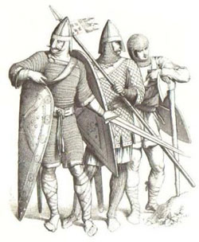
20:Robert Fitzgilbert De Clare was the first Norman king of Leinster. By what name is he better known? Strongbow. Strongbow is buried in Christchurch Cathedral, Dublin.
21:Who was the last high King of Ireland? Rory O’Connor.
22:How many counties are there in Ulster? 9
23: In what county was St. Brigid born? Co. Louth.
24: Name the largest of the four provinces. Munster
25:What make of car, which was manufactured in Belfast, was used to travel through time in Back to the Future? De Lorean.
26: Excluding Australia, what is the twentieth largest island in the world? Ireland.
27:Who was the first Irish person to climb Mount Everst?
On the 27th May, 1993 Dawson Stelfox became the first Irish person to stand on the summit of Mount Everest.
28:When did RTE {Radio Teilifis Eireann.]first broadcast? 1961
29:Name Ireland’s second highest mountain outside the McGillicuddy Reeks? Mount Brandon.County Kerry
30:What county formed the ancient kingdom of Ossory? Kilkenny
31: Who won “I’m a Celebrity. Get me out of here!”?
Carol “Foggy” Fogarty.
32: Which Irish soccer player was nominated for best goal of the year 2014? Stephanie Roche.
33: Who won the Ladies Gaelic All Ireland football final 2014? Cork
34: Who won The X factor 2014? Ben Haenow.
35: In Irish Legend, which Irish Queen went to war over the brown bull of Cooley? Queen Maeve of Connaught.
36: What is An Crannchur Naisiunta? The National Lottery.
37: Can you name the three counties in Ulster that are not part of Northern Ireland? Donegal, Cavan and Monaghan.
38: In Ireland we spell the drink “whiskey.” How is it spelt in Scotland? Whisky [No “e”]
40: On which race course is the Irish derby run each year?
The Curragh in Kildare.
41: Which county in Ireland is bordered by the most counties?
Tipperary. Eight counties border Tipperary.
42: What caused the ocean liner Lusitania to sink off the coast of County Cork in 1915? The Germans torpedoed it.
43: How many funnels were on the Titanic? Four. Three were real but the fourth was not. It was a false funnel which was put in to improve the appearance of the Titanic.
44: What fabric is obtained from the flax plant? Linen.
45:What kind of animal is crowned “King Puck” at the annual Puck Fair in KIllorgan Co. Kerry? A goat.
46: What sport is UFC? Ultimate Fighting Championship.
Conor McGregor current Irish Champion. MMA Mixed Martial Arts
47:What English leader was responsible for killing the garrison at Drogheda in 1649? Oliver Cromwell.
48: Tyres bearing this man’s name are still being manufactured. Who invented the pneumatic-air filled – tyre in 1888? John Boyd Dunlop.
49: Off which county’s coast is Lambay Island? Co. Dublin.
50: The ruins of Clonmacnoise monastery can be found on the banks of which river? The Shannon.
